LLP ERASMUS  Partner Institution Information Form |  | Universidade de Santiago de Compostela (USC) | 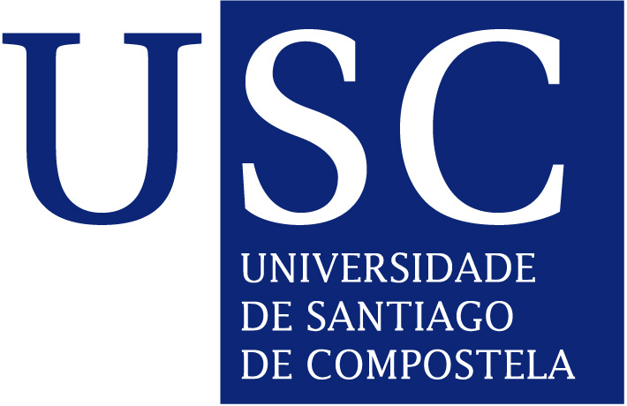
Name of the Institution |  | Universidade de Santiago de Compostela
Institution Code |  | E SANTIAG 01
Website |  | www.usc.es
Vice Chancellor |  | Juan Jose Casares Long
University courses:  Term calendars:  Study Programmes: |  | http://www.usc.es/en/titulacions/index.html  http://www.usc.es/en/perfis/estudantes/calendarios.html  http://www.usc.es/gl/titulacions/titulaionoficgrao.html
External Relations Office | Head | Enrique López Veloso  Institutional Coordinator
External Relations Office | Address | Casas Reais, nº 8  15782 Santiago de Compostela  España
External Relations Office | Phone | +34 981 584 989
External Relations Office | Fax | +34 981 578 017
External Relations Office | E-mail | ore@usc.es
External Relations Office | Website | www.usc.es/ore: http://www.usc.es/gl/servizos/ore/ErasmusIncoming.html
External Relations Office | Officers | Head of Section: María García Penas  Administrative Officer:Gloria Ventosa  Begoña Soneira  Adela Lopez  Anne Forryan
External Relations Office | Local Office at the Campus of Lugo | María del Mar Abarca Rodríguez (relext@usc.es)  Phone: +34 982 285 900 - Ext. 23569  Fax: +34 982 285 907
Application Procedure | Deadlines | 1st semester and full year: 30 June  2nd semester: 31 December
Application Procedure | Forms and Documents | - Student applications:  - https://www.usc.es/xescampusIntercambioExterna/erasmus/index.htm
Health Insurance | EU students | Students must bring the European Health card
Health Insurance | non EU students | Initial private insurance
Health Insurance | ALL students | The USC offers a student insurance (approx 14 euros) available on enrolment.
Spanish Courses (different levels) | Taught at: | Centro de Lenguas Modernas (CLM)  Facultade de Filoloxía  Avenida de Castelao s/n  15782 Santiago de Compostela
Spanish Courses (different levels) | Registration and enrolment | http://www.usc.es/gl/servizos/clm/cursos/espanol/matricula/index.html  All students have to take a placement test before enrolling.
Spanish Courses (different levels) | Types | Intensive course:  September – 4 weeks – 2 hours a day  February – 3 weeks – 3 hours a day  Term course:  October to January – 3 hours a
Spanish Courses (different levels) | Teaching hours | 40
Spanish Courses (different levels) | ECTS | 4
Spanish Courses (different levels) | Fees | First course for free. Additional courses: 50 € each. Students have to buy course book and other material needed.
Language of Instruction |  | Spanish or Galician.  It is up to the teaching staff to decide. However, most of them will be willing to teach in Spanish if they are asked to.  NO COURSES IN ENGLISH AVAILABLE, except those related to English Studies.
Accommodation | On Campus | Online-application for whole academic year only– Deadline:end April; exact details at:  http://www.usc.es/gl/servizos/sur/convocat_mobilidade.html  Campus maps: http://www.usc.es/es/info_xeral/localizacion/index.html
Accommodation | Off Campus | Information and support: maria.garcia.penas@usc.es  http://www.xornal.usc.es/xornal/taboleiro.html
Approximate Expenses per month | Accommodation | Approx. 300 €
Approximate Expenses per month | Food | 1 Meal at the University’s restaurants: 8 €  In other restaurants:10-15 €
Approximate Expenses per month | Public Transport | 1 single urban bus ticket: 1 €  10 tickets: 6 €  30 tickets: 18 €  20% off on all train tickets
Approximate Expenses per month | Entertainment | Cinema– 7 €  Theatre:10 – 40 €  Going out: approx. 30 €
Activity programme for new students
http://www.usc.es/es/goberno/vrrelins/portal_internacional/acts_visitantes.html

