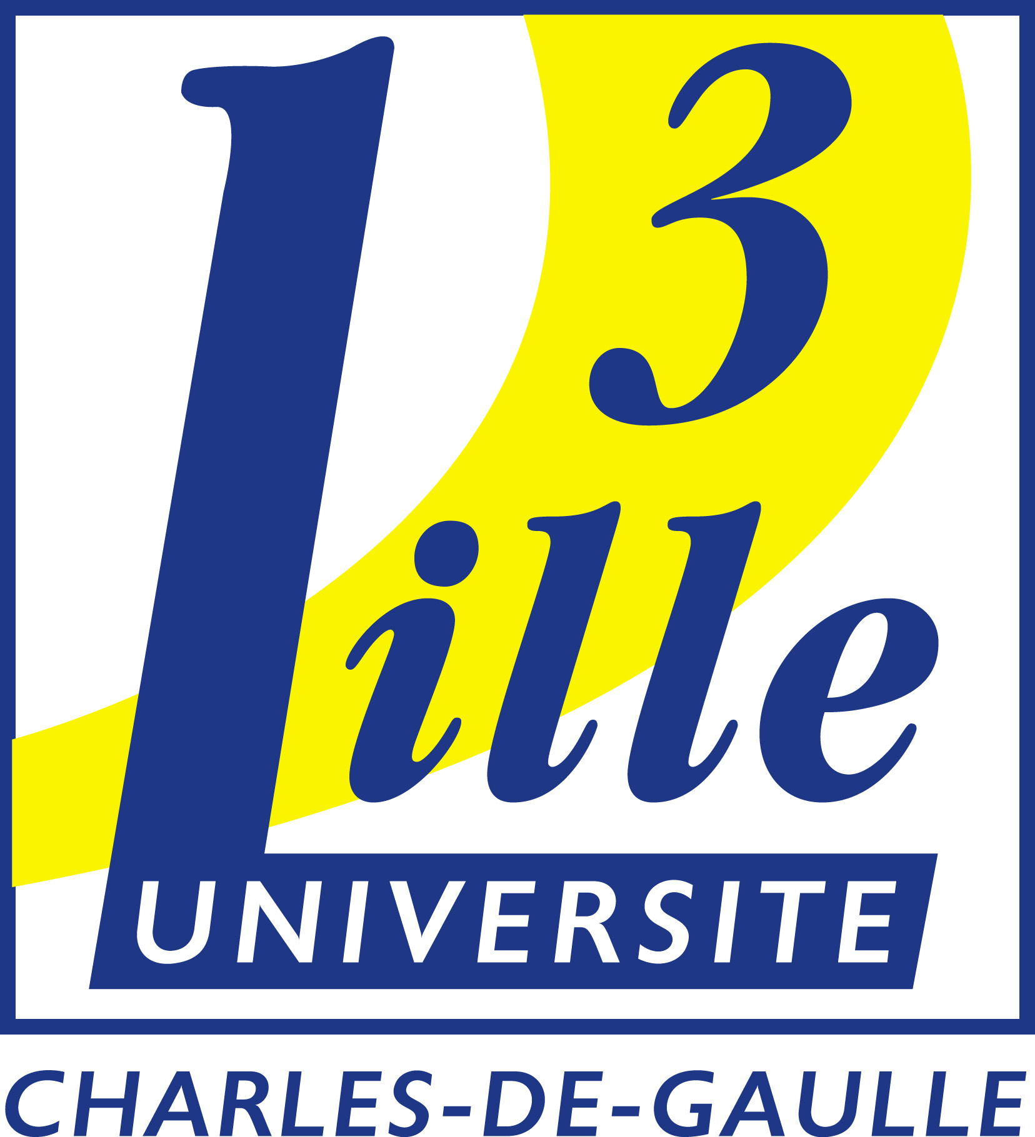
STUDENT EXCHANGE PROGRAMME
Partner University Data Sheet
Année Universitaire 2010-2011

General Information:

Name of Institution Université Charles de Gaulle – Lille 3
Erasmus Code F LILLE 03
Head of Institution Mr Jean-Claude DUPAS

Address Université Lille 3
Domaine du Pont de Bois
Service Relations Internationales
Bureau des étudiants arrivant en programmes d’échanges
Bâtiment A – Bureau A2.303
59653 Villeneuve d’Ascq Cedex

Fax +33320416390
Phone +33320416667
Website www.univ-lille3.fr

International Relations Office Contacts:

Head of International Relations Office / Ms Norah DEI CAS
LLP Institutional Coordinator ri.direction@univ-lille3.fr

Administrative Officer / Teaching Mobility Mr Vincent BAUDRY
Tel/Fax: +33320416308/+33320416390
vincent.baudry@univ-lille3.fr

Bilateral Agreements Ms Martine HAMIACHE
Tel/Fax: +33320416663/+33320416390
martine.hamiache@univ-lille3.fr

Incoming Exchange students Ms Cyrielle ROHART/Mr José LAGOS LAMA
Tel/Fax: +33320416667/+33320416390
incoming@univ-lille3.fr

Outgoing Erasmus students Ms Karine WATREMEZ/Mr Marc FALEMPIN
Tel/Fax: +33320416391/+33320416390
erasmus@univ-lille3.fr

Exchange Related Information:

Application procedure Exchange students must send within the deadline:
Application form and Learning Agreement.
Application form http://www.univ-lille3.fr/fr/international/venir-etudier/programme-echange/candidater/
Application deadlines -Autumn semester: 15/06
-Spring semester: 15/11

Visa requirements All Non-European students must be provided with a VISA.

Language / Certificates Requirements Recommended level of knowledge of French language at the beginning of the Erasmus period: B2

Recommended arrival dates -Autumn semester: First week of September
-Spring semester: First week of January

Course registration Exchange students are matriculated by the International Relations Office. There is no need registration for courses, but students must register in order to take exam.

Educational and Practical Informations:

International Relations Office Website http://www.univ-lille3.fr/fr/international/venir-etudier/programme-echange/

Language(s) of instruction French (except for the language departments).

Intensive language courses Courses of French language for foreign students are offered by DEFI.
http://www.univ-lille3.fr/fr/international/venir-etudier/programme-echange/candidater/cours-fle-etudiants-echange/

Housing information Accommodation in university residences is offered by the University of Lille 3, within a limited number of places.

Guide for International Incoming Students http://www.univ-lille3.fr/fr/international/venir-etudier/guide-accueil/

